Voltage Conversion / Regulation

Quick Comparison:
Type | Picture | Advantages | Disadvantages
Linear Regulator | 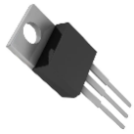 | - Low cost  - Low noise  - Small packaging | - Can only step down voltage.  - Low efficiency (burns off excess voltage)  - High heat generation  - Cannot be used in most power circuits
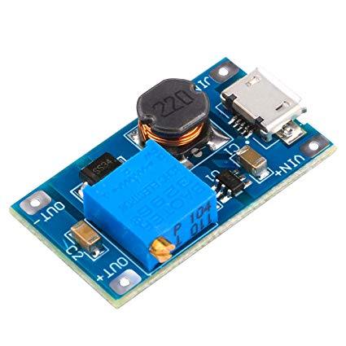  Buck Converter | 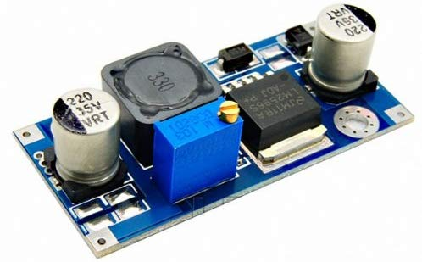 | - Vout can be much lower than Vin  - High efficiency | - Can only step down voltages  - More complicated  - Higher cost  - Large size  - High noise (bad for sensitive sensors)
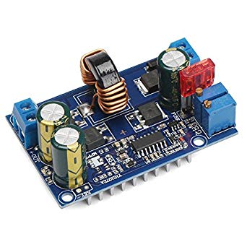  Boost Converter |  | - Can have higher output than input  - Decent efficiency | - Can only step up voltages  - More complicated  - Higher cost  - Large size  - High noise (bad for sensitive sensors)
Buck-Boost Converter (Inverter) |  | - Can have higher or lower output  - Decent efficiency | - Can step voltage up or down  - More complicated  - Higher cost  - Large size  - High noise (bad for sensitive sensors)

The Project Support Center stocks the following linear regulators and Buck converters:
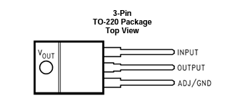
LM1117 Linear regulators:
Vmax Input: 25V
Output Voltage: 3.3 or 5V
Max Continuous Power Dissipation: 1W
Linear regulators are the least expensive and most compact form of regulator. They act like a resistor that “burns off” excess voltage as heat to produce the desired output voltage. The amount of energy lost (W) is given by (Vin – Vout)*(Current). These regulators cannot exceed ~1 watt without overheating. For example, with a 12V input, the max current draw for the 3.3V regulator is about 115mA (12-3.3*115mA=1W) or 140mA for the 5V regulator. It is strongly recommended that you do not exceed the specifications above. Drawing too much current will cause the regulator to overheat and stop regulating which allows the full unregulated voltage to pass and may fry components on your circuit.

LM2596 Buck Converter:
Input Voltage Range: 3.2V – 35V
Output Voltage Range: 1.25V – 30V (Output voltage must be 1.5V lower than input voltage)
Max Current Draw: 3A
Buck converters are much more efficient than linear regulators. Rather than “burning off” the extra voltage as heat, they rapidly switch the supply voltage on and off and use a capacitor to smooth the signal, much like using PWM. They are slightly more expensive but can handle higher power requirements. Note: using this buck converter with sensors that are sensitive to noise can cause sporadic sensor issues (we’ve previously seen issues with the IR prox sensor (noise pulses causing “false” counts), QRD output and Sharp distance sensors).

